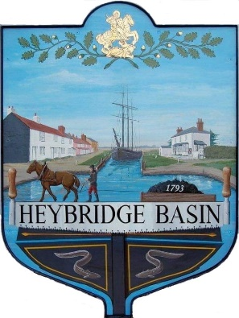
HEYBRIDGE BASIN PARISH COUNCIL
Action Plan 2023-2024

Heybridge Basin Parish Council constantly strives to work on behalf of the residents on the issues that matter to the parish. The Council is keen to receive ideas and suggestions from residents on areas of interest or concern and where it is felt the Council may assist.
The Parish Council will publish an action plan annually at the beginning of each Municipal year. The plan will be drawn from the budget which is set in November/December, which includes project expenditure for the forthcoming year and from matters raised by residents.
The Parish Council will continually review the action plan and will add any matters as required through the year. The Action Plan will be formally reviewed by the Council on a quarterly basis, to include an update on the matters identified, addition of any further appropriate actions identified during the quarter and signing off any completed.

ACTIVITIES & ACTION | BUDGET CODE | TIMESCALE | ACTION TO DATE - PROGRESS | DATE COMPLETED
Grounds maintenance | Grounds Maintenance | On going | On going maintenance, such as weeding, trimming hedges, bushes, and verges, emptying of litter and dog bins. | N/A
Good governance of the Parish | Elections  Training | On going | Elections, Councillors attending training courses, staff continue to further professional development. | N/A
Quarterly Newsletter | N/A | On going | Council continues to work on a quarterly community newsletter | N/A
Donations | Chair Allowance  S137 | On going | The council continues to support charities and local groups | N/A
Goal Posts and basketball hoops – St George’s Field | FA Grant  MDC Match funding | Summer 2023 | FA Grant approved. Agreed with MDC ¾ size goals. Liaise with MDC regarding Insurance.
Community Speed Watch |  | TBC | Register with Community speed watch scheme and advertise for at least 10 volunteers.
Felling of 6 Leylandii – DMCP | DMCP Income | End of nesting season | Planning permission granted. Consider quotes for works and agree a date. Consider what to replace with.
Resurfacing Access Road – DMCP | DMCP Income | TBC | Submit a planning application to MDC. Create a Tender specification and put on gov find a tender website.
Bench near Bus Shelter | Asset Maintenance | July 2023 | Awaiting quote to sand and varnish old slats to match repaired slat.
Land adjacent St George’s Church | Legal & Professional | TBC | Adverse possession application submitted. Awaiting info from HM Land Registry Office.
Pedestrian Sign – St George’s Close |  | TBC | Liaising with MDC.
Neighbourhood Plan and Village Design Statement |  | TBC | To set up a WG and review.
On-Street parking |  | On going
Coronation Plaque | Chair Allowance | June 2023

Reviewed and adopted: 16th May; Minute 23/15 a

